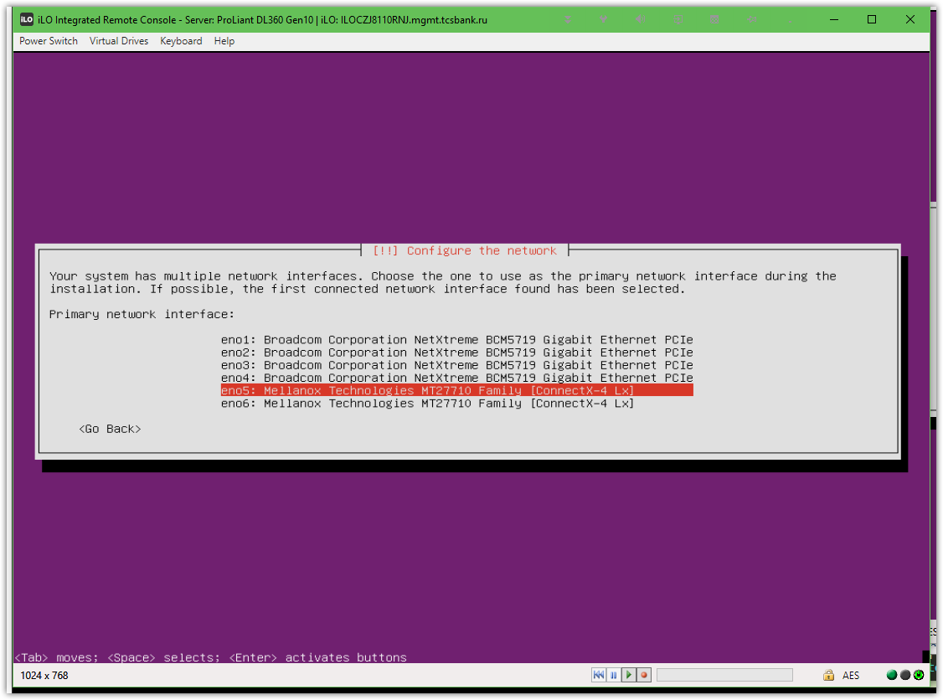
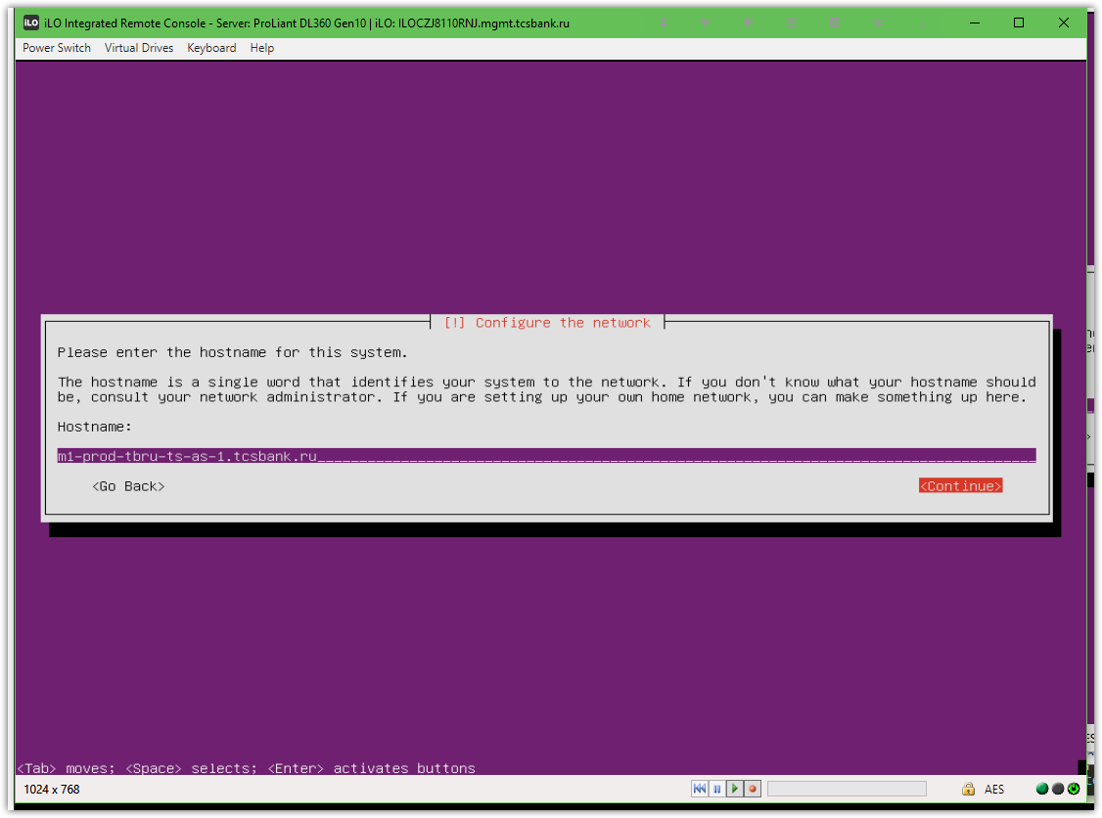

# Here needs to choose “Yes”!
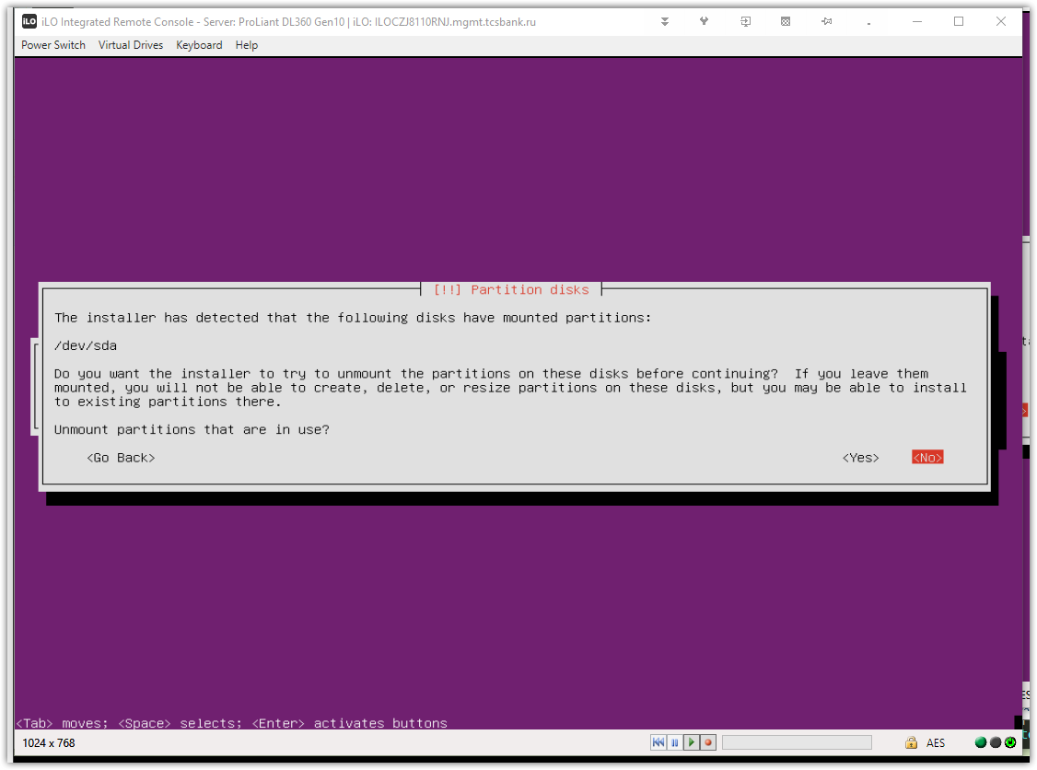
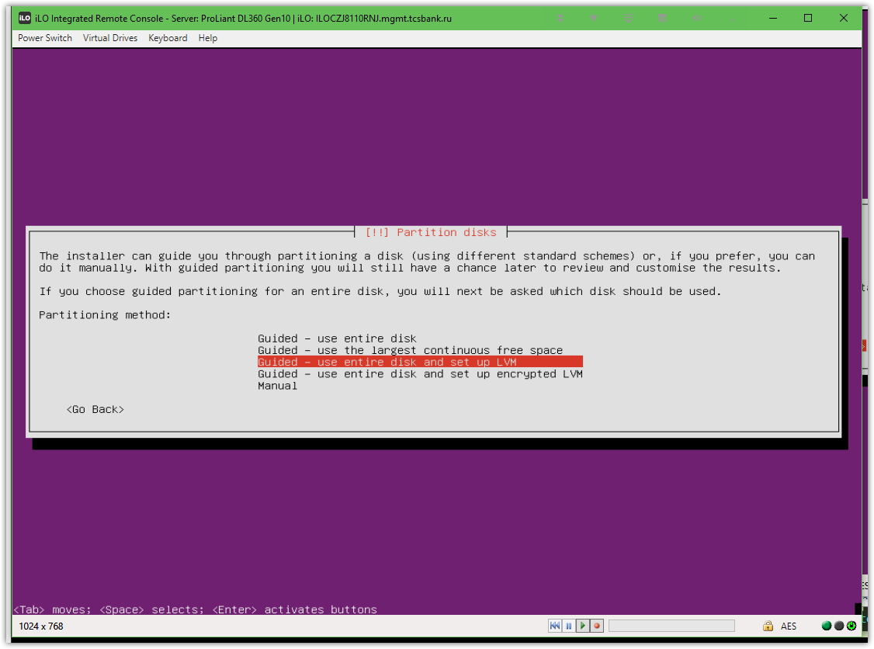
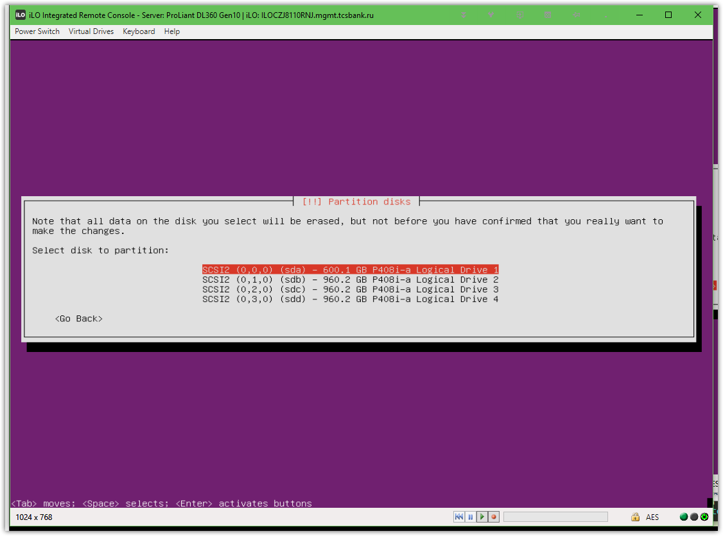

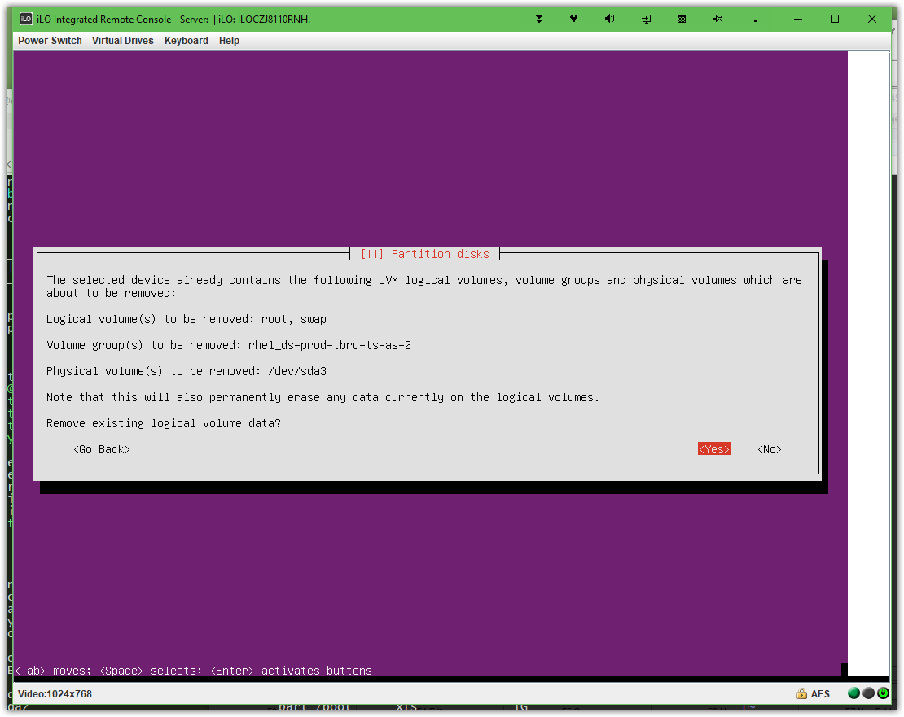

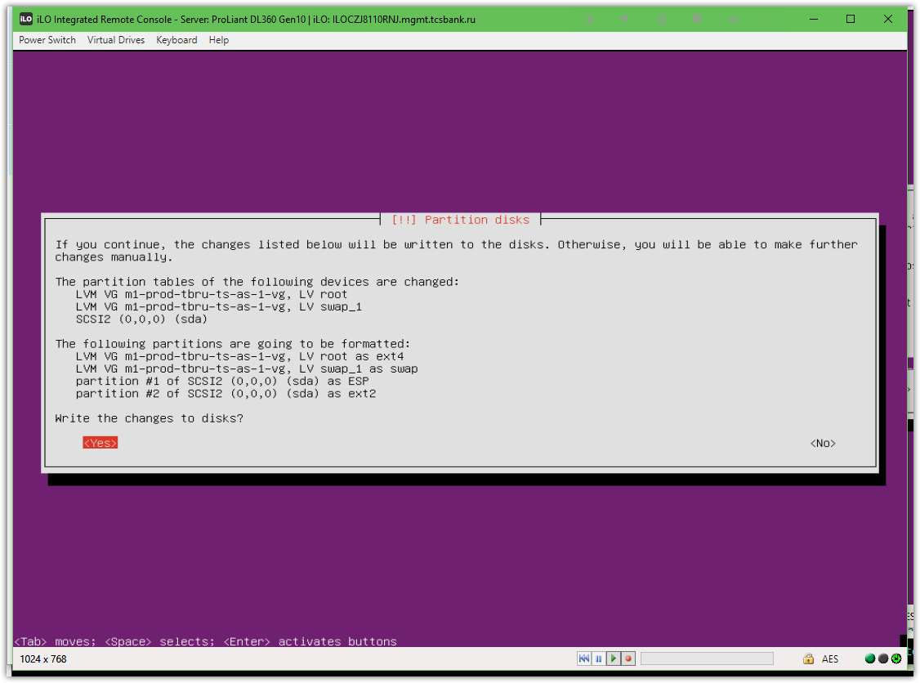

# If here not to choose “yes”, this server will not boot… (by default in BIOS thise servers use UEFI mode).
# It’s need to choose “yes”.
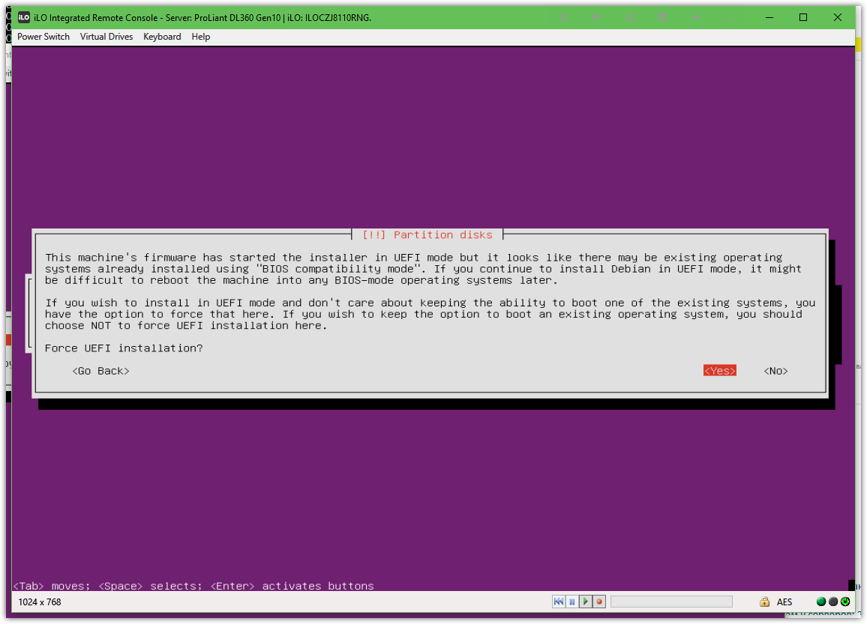

#
# During installation it’s strongly must be selected “OpenSSH server”!!!
# If this not selected - we stay withou ssh server.... and cannot connect to server via SSH!
# It was my mistake!
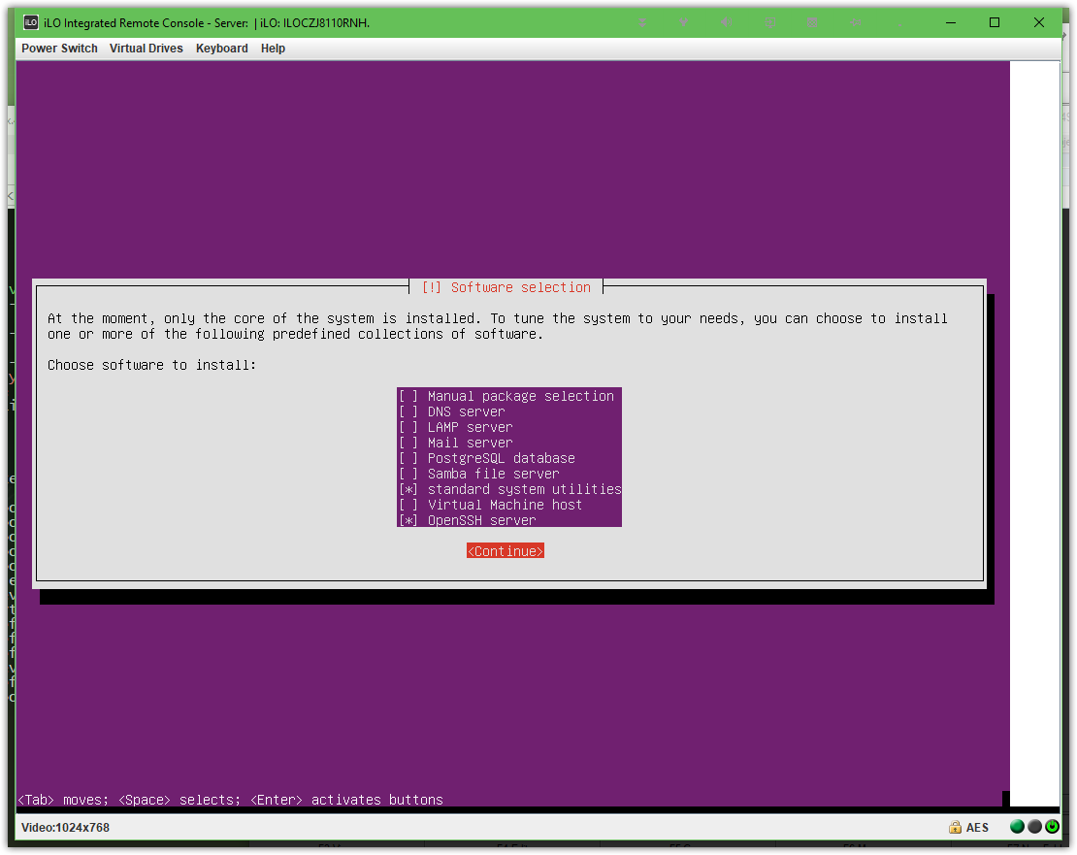

#
# What to do if I have forgotten install “OpenSSH server”.

# I was lucky.
# On both of installed servers were given PXE network in VLAN 1815.
# So, after OS was installed I have working network and ip-address was taken from DHCP server.

root@ds-prod-tbru-ts-as-1:~# ip -f inet addr | grep inet
inet 127.0.0.1/8 scope host lo
inet 10.218.15.112/24 brd 10.218.15.255 scope global eno5
root@ds-prod-tbru-ts-as-1:~#

# I’ve tested access to repo-linux server - and it was available!
# DNS servers are working well, so I’ve thought we have access to our repository too.
#
root@ds-prod-tbru-ts-as-1:~# host repo-linux.tcsbank.ru
repo-linux.tcsbank.ru is an alias for ds-repo01.tcsbank.ru.
ds-repo01.tcsbank.ru has address 10.216.42.6
root@ds-prod-tbru-ts-as-1:~#

# I’ve written follow line to the file.
root@ds-prod-tbru-ts-as-1:~# cat /etc/apt/apt.conf
Acquire::http::Proxy "http://repo-linux.tcsbank.ru:80";
root@ds-prod-tbru-ts-as-1:~#

#
# I’ve loocked into the file of our puppet 3:
# [root@puppet ~]# vim /etc/puppet/modules/tcs_repos/templates/sources-general.list.rb
# In this file I’ve found what to replace.
#
# I’ve replaced all patterns in the file via follow commands
# :%s/us.archive.ubuntu.com/repo-linux.tcsbank.ru/gc
# :%s/security.ubuntu.com/repo-linux.tcsbank.ru/gc
#
# The file become like follow.
#
root@ds-prod-tbru-ts-as-1:~# vim /etc/apt/sources.list
#

# deb cdrom:[Ubuntu-Server 16.04 LTS _Xenial Xerus_ - Release amd64 (20160420.3)]/ xenial main restricted

#deb cdrom:[Ubuntu-Server 16.04 LTS _Xenial Xerus_ - Release amd64 (20160420.3)]/ xenial main restricted

# See http://help.ubuntu.com/community/UpgradeNotes for how to upgrade to
# newer versions of the distribution.
deb http://repo-linux.tcsbank.ru/ubuntu/ xenial main restricted
# deb-src http://repo-linux.tcsbank.ru/ubuntu/ xenial main restricted

## Major bug fix updates produced after the final release of the
## distribution.
deb http://repo-linux.tcsbank.ru/ubuntu/ xenial-updates main restricted
# deb-src http://repo-linux.tcsbank.ru/ubuntu/ xenial-updates main restricted
....

#
# Next will be simple.
apt-get update

# I’ve added one line.
root@ds-prod-tbru-ts-as-1:~# grep -e "^PermitRootLogin" /etc/ssh/sshd_config
PermitRootLogin yes
root@ds-prod-tbru-ts-as-1:~#

apt-get install openssh-server

# After that I’ve connected via ssh to server!

#
# To use ansible we need to install two packages:
root@m1-prod-tbru-ts-as-1:~# apt-get install python
root@m1-prod-tbru-ts-as-1:~# apt-get install python-apt
# But we can do it without access to our local repositories…
# To fix it I’ve copied file with description of our local repositories.
root@ds-prod-tbru-ts-as-2:~# cat /etc/apt/sources.list
# Ansible managed: b'/data/jenkins/workspace/infra-ts-common/deploy/roles/_apt/templates/xenial_sources.list.j2' on vm-prod-tbru-ts-ops-1.tcsbank.ru

deb http://repo-linux.tcsbank.ru/ubuntu/ xenial main restricted
# deb-src http://repo-linux.tcsbank.ru/ubuntu/ xenial main restricted

deb http://repo-linux.tcsbank.ru/ubuntu/ xenial-updates main restricted
# deb-src http://repo-linux.tcsbank.ru/ubuntu/ xenial-updates main restricted

deb http://repo-linux.tcsbank.ru/ubuntu/ xenial universe
# deb-src http://repo-linux.tcsbank.ru/ubuntu/ xenial universe

deb http://repo-linux.tcsbank.ru/ubuntu/ xenial-updates universe
# deb-src http://repo-linux.tcsbank.ru/ubuntu/ xenial-updates universe

deb http://repo-linux.tcsbank.ru/ubuntu/ xenial multiverse
# deb-src http://repo-linux.tcsbank.ru/ubuntu/ xenial multiverse

deb http://repo-linux.tcsbank.ru/ubuntu/ xenial-updates multiverse
# deb-src http://repo-linux.tcsbank.ru/ubuntu/ xenial-updates multiverse

deb http://repo-linux.tcsbank.ru/ubuntu/ xenial-backports main restricted universe multiverse
# deb-src http://repo-linux.tcsbank.ru/ubuntu/ xenial-backports main restricted universe multiverse

# deb http://archive.canonical.com/ubuntu xenial partner
# deb-src http://archive.canonical.com/ubuntu xenial partner

deb http://repo-linux.tcsbank.ru/ubuntu xenial-security main restricted
# deb-src http://repo-linux.tcsbank.ru/ubuntu xenial-security main restricted

deb http://repo-linux.tcsbank.ru/ubuntu xenial-security universe
# deb-src http://repo-linux.tcsbank.ru/ubuntu xenial-security universe

deb http://repo-linux.tcsbank.ru/ubuntu xenial-security multiverse
# deb-src http://repo-linux.tcsbank.ru/ubuntu xenial-security multiverse
root@ds-prod-tbru-ts-as-2:~#

# In addition I’ve defined the proxy. Sometime it’s not need to do, but anyway - I did it.
root@ds-prod-tbru-ts-as-2:~# cat /etc/apt/apt.conf
Acquire::http::Proxy "http://repo-linux.tcsbank.ru:80";
root@ds-prod-tbru-ts-as-2:~#

# After that, command to update repositories start working.
root@ds-prod-tbru-ts-as-2:~# apt-get update

# I’ve installed two packages.
root@m1-prod-tbru-ts-as-1:~# apt-get install python
root@m1-prod-tbru-ts-as-1:~# apt-get install python-apt
# After that, ansible had started work.

[support@centos 20180525-1714]$ cat 20180626-1852.install.puppet-agent.yaml
---
- hosts: all

vars:
puppetserver: vm-puppetmaster02p.tcsbank.ru

tasks:

- name: Add Puppetlabs Repo v5 (rpm) for RHEL
yum_repository:
name: tcs-puppetlabs
description: Puppetlabs Repo (rpm)
baseurl: http://repo-linux.tcsbank.ru/puppetlabs/yum/puppet5/el/{{ ansible_distribution_major_version }}/$basearch
skip_if_unavailable: yes
repo_gpgcheck: no
gpgcheck: no
when: ansible_os_family == "RedHat"

- name: Add Puppetlabs Repo v5 (deb)
apt_repository:
filename: 'tcs-puppet5'
repo: "deb http://repo-linux.tcsbank.ru/puppetlabs/apt/ {{ ansible_lsb.codename|lower }} puppet5"
when: ansible_os_family == "Debian"

- name: Add Puppetlabs Repo key (deb)
apt_key:
url: "http://repo-linux.tcsbank.ru/puppetlabs/apt/pubkey.gpg"
when: ansible_os_family == "Debian"

- name: Install puppet-agent via apt module on Ubuntu with option -y
apt:
name: puppet-agent
allow_unauthenticated: yes
state: present
when: ansible_distribution == "Ubuntu"

- name: Install new puppet
package:
name: puppet-agent
state: present
when: not ansible_distribution == "Ubuntu"

- name: Set puppet server in config
shell: "/opt/puppetlabs/bin/puppet config set server {{ puppetserver }}"

- name: Enable agent (for ubuntu)
shell: puppet agent --enable
ignore_errors: yes
when: ansible_distribution == "Ubuntu"

- name: First run puppet
puppet:
ignore_errors: yes

[support@centos 20180525-1714]$ cat 20180626-1852.list_of_hosts
[all]
10.218.15.111
[support@centos 20180525-1714]$

#
# Everything looks good, but there is no access to puppet servers from our servers if they have only VLAN 1815.
#
[support@centos 20180525-1714]$ ansible-playbook 20180626-1852.install.puppet-agent.yaml -i 20180626-1852.list_of_hosts --become --extra-vars "ansible_user=bsv ansible_password=$(pass common/linux) ansible_sudo_pass=$(pass common/linux) ansible_ssh_common_args='-oStrictHostKeyChecking=no -oPubkeyAuthentication=no'"

PLAY [all] **********************************************************************************************************************************************************************************************

TASK [Gathering Facts] **********************************************************************************************************************************************************************************
ok: [10.218.15.111]

TASK [Add Puppetlabs Repo v5 (rpm) for RHEL] ************************************************************************************************************************************************************
skipping: [10.218.15.111]

TASK [Add Puppetlabs Repo v5 (deb)] *********************************************************************************************************************************************************************
changed: [10.218.15.111]

TASK [Add Puppetlabs Repo key (deb)] ********************************************************************************************************************************************************************
ok: [10.218.15.111]

TASK [Install puppet-agent via apt module on Ubuntu with option -y] *************************************************************************************************************************************
changed: [10.218.15.111]

TASK [Install new puppet] *******************************************************************************************************************************************************************************
skipping: [10.218.15.111]

TASK [Set puppet server in config] **********************************************************************************************************************************************************************
changed: [10.218.15.111]

TASK [Enable agent (for ubuntu)] ************************************************************************************************************************************************************************
fatal: [10.218.15.111]: FAILED! => {"changed": true, "cmd": "puppet agent --enable", "delta": "0:00:00.001200", "end": "2018-06-26 12:10:43.165982", "msg": "non-zero return code", "rc": 127, "start": "2018-06-26 12:10:43.164782", "stderr": "/bin/sh: 1: puppet: not found", "stderr_lines": ["/bin/sh: 1: puppet: not found"], "stdout": "", "stdout_lines": []}
...ignoring

TASK [First run puppet] *********************************************************************************************************************************************************************************
fatal: [10.218.15.111]: FAILED! => {"changed": false, "disabled": false, "error": true, "msg": "puppet did not run", "rc": 1, "stderr": "Error: Could not request certificate: execution expired\n", "stderr_lines": ["Error: Could not request certificate: execution expired"], "stdout": "Info: Creating a new SSL key for m1-prod-tbru-ts-as-1.tcsbank.ru\nExiting; failed to retrieve certificate and waitforcert is disabled\n", "stdout_lines": ["Info: Creating a new SSL key for m1-prod-tbru-ts-as-1.tcsbank.ru", "Exiting; failed to retrieve certificate and waitforcert is disabled"]}
...ignoring

PLAY RECAP **********************************************************************************************************************************************************************************************
10.218.15.111 : ok=7 changed=4 unreachable=0 failed=0

[support@centos 20180525-1714]$

root@m1-prod-tbru-ts-as-1:~# puppet agent -t
Notice: Caught INT; exiting
root@m1-prod-tbru-ts-as-1:~# cat /etc/puppetlabs/puppet/puppet.conf
[main]
server = vm-puppetmaster02p.tcsbank.ru
# This file can be used to override the default puppet settings.
# See the following links for more details on what settings are available:
# - https://puppet.com/docs/puppet/latest/config_important_settings.html
# - https://puppet.com/docs/puppet/latest/config_about_settings.html
# - https://puppet.com/docs/puppet/latest/config_file_main.html
# - https://puppet.com/docs/puppet/latest/configuration.html
root@m1-prod-tbru-ts-as-1:~# telnet vm-puppetmaster02p.tcsbank.ru 8140
Trying 10.216.40.228...

root@m1-prod-tbru-ts-as-1:~#

#
# It’s time to change ip addresses from PXE VLAN 1815 to persistent for servers.
#

#
# I’ve changed file interfaces configuration from below.
#
root@m1-prod-tbru-ts-as-1:~# cat ~/work/20180627-1609/interfaces
# This file describes the network interfaces available on your system
# and how to activate them. For more information, see interfaces(5).

source /etc/network/interfaces.d/*

# The loopback network interface
auto lo
iface lo inet loopback

# The primary network interface
auto eno5
iface eno5 inet dhcp
root@m1-prod-tbru-ts-as-1:~#

#
# To this.
#
root@m1-prod-tbru-ts-as-1:~# cat /etc/network/interfaces
# This file describes the network interfaces available on your system
# and how to activate them. For more information, see interfaces(5).

source /etc/network/interfaces.d/*

# The loopback network interface
auto lo
iface lo inet loopback

# The primary network interface
# auto eno5
# iface eno5 inet dhcp

auto eno5
iface eno5 inet manual
bond-master bond0
bond-primary eno5

auto eno6
iface eno6 inet manual
bond-master bond0

auto bond0
iface bond0 inet manual
bond-mode 1
bond-miimon 100
bond-slaves none

auto bond0.1803
iface bond0.1803 inet static
address 10.218.3.161
netmask 255.255.255.0
gateway 10.218.3.254

dns-search tcsbank.ru
dns-nameservers 10.216.42.5 10.216.40.4

root@m1-prod-tbru-ts-as-1:~#

#
# Next step I did follow.
# I’ve restarted network.
# Methods was found here: https://linuxconfig.org/how-to-restart-network-on-ubuntu-16-04-xenial-xerus-linux
#

root@ds-prod-tbru-ts-as-1:~# /etc/init.d/networking restart
Restarting networking (via systemctl): networking.serviceConnection reset by 10.218.15.112
[s.belogrud@TCS4357]#

# Connection was lost, but now I have follow working ip-addresses.
#
root@m1-prod-tbru-ts-as-1:~# ip -f inet addr | grep inet
inet 127.0.0.1/8 scope host lo
inet 10.218.15.111/24 brd 10.218.15.255 scope global eno5
inet 10.218.3.161/24 brd 10.218.3.255 scope global bond0.1803
root@m1-prod-tbru-ts-as-1:~#

#
# After network was changed. It’s need not to do some changes on puppet, because of puppet use certificate and it not depend from server’s ip address.
#
root@m1-prod-tbru-ts-as-1:~# puppet agent -t
Info: Using configured environment 'production'
Info: Retrieving pluginfacts
Info: Retrieving plugin
Info: Loading facts
Info: Caching catalog for m1-prod-tbru-ts-as-1.tcsbank.ru
Info: Applying configuration version 'vm-puppetmaster02p.tcsbank.ru-production-f7d5cef72cb'
Notice: Applied catalog in 0.81 seconds
root@m1-prod-tbru-ts-as-1:~#

#
# 20180814
#
https://downloads.linux.hpe.com/SDR/project/mcp/
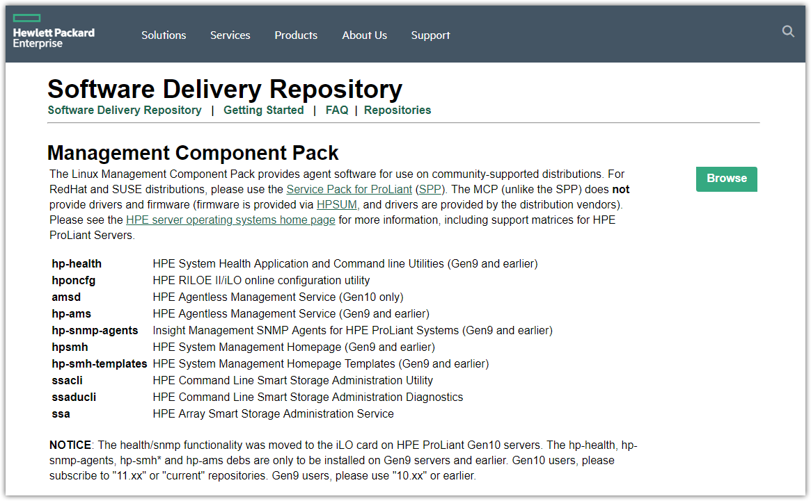
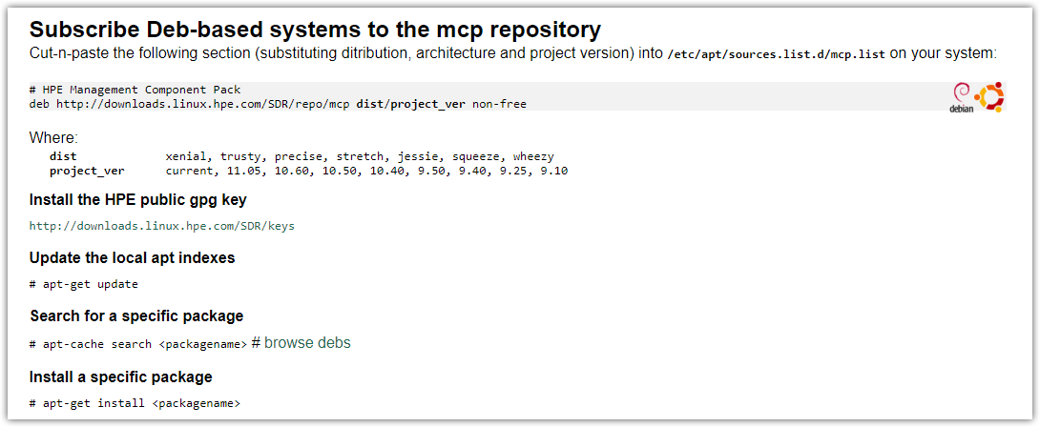

root@ds-prod-tbru-ts-as-1:~# cat /etc/apt/sources.list.d/mcp.list
# HPE Management Component Pack
deb http://downloads.linux.hpe.com/SDR/repo/mcp xenial/11.05 non-free
root@ds-prod-tbru-ts-as-1:~#

root@ds-prod-tbru-ts-as-1:~# cat > /etc/apt/apt.conf
Acquire::http::Proxy "http://repo-linux.tcsbank.ru:80";
root@ds-prod-tbru-ts-as-1:~# apt-get update

root@ds-prod-tbru-ts-as-1:~# curl -x http://repo-linux.tcsbank.ru:80 http://downloads.linux.hpe.com/SDR/hpPublicKey1024.pub | apt-key add -
% Total % Received % Xferd Average Speed Time Time Time Current
Dload Upload Total Spent Left Speed
100 1713 100 1713 0 0 4853 0 --:--:-- --:--:-- --:--:-- 4852
OK

root@ds-prod-tbru-ts-as-1:~# curl -x http://repo-linux.tcsbank.ru:80 http://downloads.linux.hpe.com/SDR/hpPublicKey2048_key1.pub | apt-key add -
% Total % Received % Xferd Average Speed Time Time Time Current
Dload Upload Total Spent Left Speed
100 268 100 268 0 0 751 0 --:--:-- --:--:-- --:--:-- 752
gpg: no valid OpenPGP data found.

root@ds-prod-tbru-ts-as-1:~# curl -x http://repo-linux.tcsbank.ru:80 http://downloads.linux.hpe.com/SDR/hpPublicKey2048.pub | apt-key add -
% Total % Received % Xferd Average Speed Time Time Time Current
Dload Upload Total Spent Left Speed
100 990 100 990 0 0 697 0 0:00:01 0:00:01 --:--:-- 698
OK

root@ds-prod-tbru-ts-as-1:~# curl -x http://repo-linux.tcsbank.ru:80 http://downloads.linux.hpe.com/SDR/hpePublicKey2048_key1.pub | apt-key add -
% Total % Received % Xferd Average Speed Time Time Time Current
Dload Upload Total Spent Left Speed
100 269 100 269 0 0 743 0 --:--:-- --:--:-- --:--:-- 743
gpg: no valid OpenPGP data found.
root@ds-prod-tbru-ts-as-1:~#

# Manually download two files of keys.
https://downloads.linux.hpe.com/SDR/keys.html

[s.belogrud@TCS4357]# scp /drives/c/Users/s.belogrud/Downloads/hpePublicKey2048_key1.pub bsv@ds-prod-tbru-ts-as-1:/tmp
hpePublicKey2048_key1.pub 100% 1004 1.0KB/s 00:00
[s.belogrud@TCS4357]# scp /drives/c/Users/s.belogrud/Downloads/hpPublicKey2048_key1.pub bsv@ds-prod-tbru-ts-as-1:/tmp
hpPublicKey2048_key1.pub 100% 994 1.0KB/s 00:00
[s.belogrud@TCS4357]#

root@ds-prod-tbru-ts-as-1:~# apt-key add /tmp/hpePublicKey2048_key1.pub
OK
root@ds-prod-tbru-ts-as-1:~# apt-key add /tmp/hpPublicKey2048_key1.pub
OK
root@ds-prod-tbru-ts-as-1:~#

root@ds-prod-tbru-ts-as-1:~# cat /etc/apt/sources.list.d/mcp.list
# HPE Management Component Pack
deb http://downloads.linux.hpe.com/SDR/repo/mcp xenial/11.05 non-free
root@ds-prod-tbru-ts-as-1:~#

root@ds-prod-tbru-ts-as-1:~# apt-get update
...
Ign:13 https://deb.datamind.ru:9003/prod-xenial xenial/main Translation-en
Err:14 https://deb.datamind.ru:9003/prod-xenial xenial/main amd64 Packages
Bad header line
Ign:15 https://deb.datamind.ru:9003/prod-xenial xenial/main i386 Packages
Ign:17 http://downloads.linux.hpe.com/SDR/repo/mcp xenial/11.05 InRelease
Get:18 http://downloads.linux.hpe.com/SDR/repo/mcp xenial/11.05 Release [6,049 B]
Get:19 http://downloads.linux.hpe.com/SDR/repo/mcp xenial/11.05 Release.gpg [490 B]
Get:20 http://downloads.linux.hpe.com/SDR/repo/mcp xenial/11.05/non-free amd64 Packages [3,371 B]
Get:21 http://downloads.linux.hpe.com/SDR/repo/mcp xenial/11.05/non-free i386 Packages [579 B]
Fetched 10.5 kB in 1s (7,790 B/s)
Reading package lists... Done
W: The repository 'https://deb.datamind.ru:9003/prod-xenial xenial Release' does not have a Release file.
N: Data from such a repository can't be authenticated and is therefore potentially dangerous to use.
N: See apt-secure(8) manpage for repository creation and user configuration details.
E: Failed to fetch https://deb.datamind.ru:9003/prod-xenial/dists/xenial/main/binary-amd64/Packages Bad header line
E: Some index files failed to download. They have been ignored, or old ones used instead.
root@ds-prod-tbru-ts-as-1:~# apt-get install ssa

root@ds-prod-tbru-ts-as-1:~# apt-get install ssa
Reading package lists... Done
Building dependency tree
Reading state information... Done
The following packages were automatically installed and are no longer required:
linux-headers-4.4.0-21 linux-headers-4.4.0-21-generic linux-image-4.4.0-21-generic
linux-image-extra-4.4.0-21-generic linux-signed-image-4.4.0-21-generic
Use 'sudo apt autoremove' to remove them.
The following NEW packages will be installed:
ssa
0 upgraded, 1 newly installed, 0 to remove and 47 not upgraded.
Need to get 7,488 kB of archives.
After this operation, 0 B of additional disk space will be used.
Get:1 http://downloads.linux.hpe.com/SDR/repo/mcp xenial/11.05/non-free amd64 ssa amd64 3.10-3.0 [7,488
kB]
Fetched 7,488 kB in 25s (288 kB/s)
[master cb0cb3d] saving uncommitted changes in /etc prior to apt run
Author: bsv <bsv@ds-prod-tbru-ts-as-1.tcsbank.ru>
4 files changed, 5 insertions(+)
create mode 100644 apt/apt.conf
create mode 100644 apt/sources.list.d/mcp.list
Selecting previously unselected package ssa.
(Reading database ... 142044 files and directories currently installed.)
Preparing to unpack .../ssa_3.10-3.0_amd64.deb ...
Unpacking ssa (3.10-3.0) ...
Processing triggers for man-db (2.7.5-1) ...
Setting up ssa (3.10-3.0) ...
insserv: warning: script 'S01hpessad' missing LSB tags and overrides
insserv: warning: script 'hpessad' missing LSB tags and overrides
insserv: warning: current start runlevel(s) (2) of script `hpessad' overrides LSB defaults (2 3 4 5).
insserv: warning: current stop runlevel(s) (empty) of script `hpessad' overrides LSB defaults (0 1 6).
[master d7bb60e] committing changes in /etc after apt run
Author: bsv <bsv@ds-prod-tbru-ts-as-1.tcsbank.ru>
3 files changed, 85 insertions(+)
create mode 100755 init.d/hpessad
create mode 120000 rc2.d/S02hpessad
root@ds-prod-tbru-ts-as-1:~#

root@ds-prod-tbru-ts-as-1:~# ssa
Smart Storage Administrator 3.10.3.0 2017-05-17
Command Line Functions:
-local : Run ssa application
ssa -local
Run the application in English.
ssa -local [ -lang languageCode ]
Run the application in the language specified by languageCode.
Supported languageCode/languages are:
...

#
# It looks like it useless to get info about raid controller config....
root@ds-prod-tbru-ts-as-1:~# ssa -local
Smart Storage Administrator 3.10.3.0 2017-05-17

root@ds-prod-tbru-ts-as-1:~#

